**AWS CLOUD COMPUTING**

**Practical no.6**

**AIM:** *Create Elastic Beanstalk Server with NodeJs as platform and run sample applications on it.*

# **Step 1.**First go to the AWS console and search for Elastic Beanstalk.

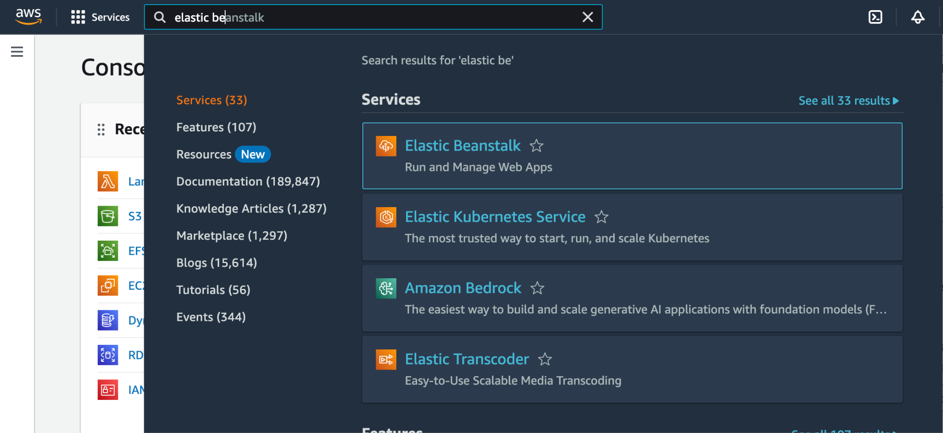

# **Step 2.** Click on the create application option and run a sample application say application6.

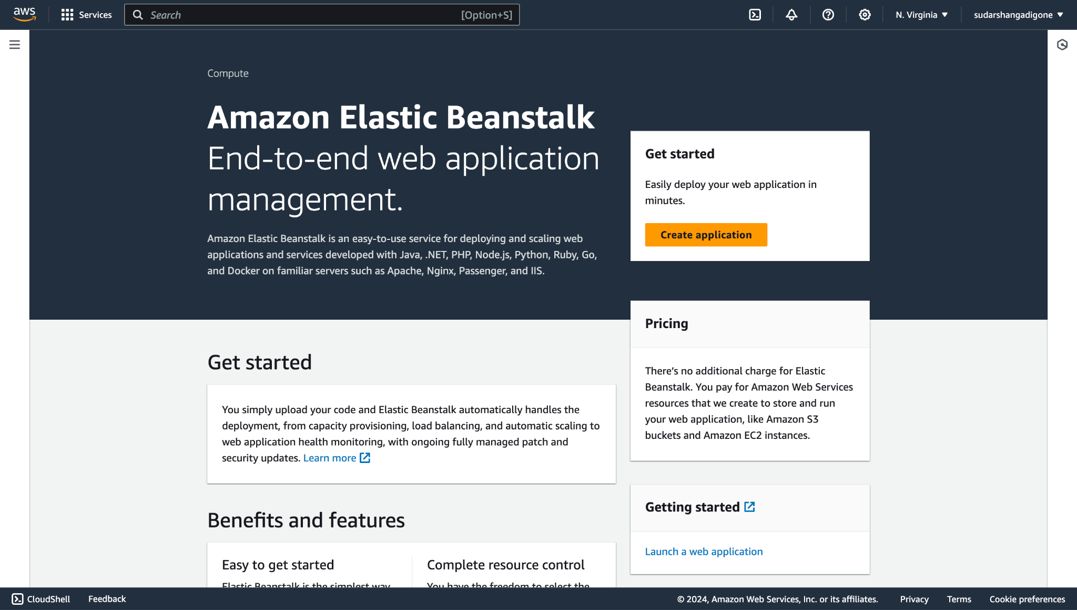

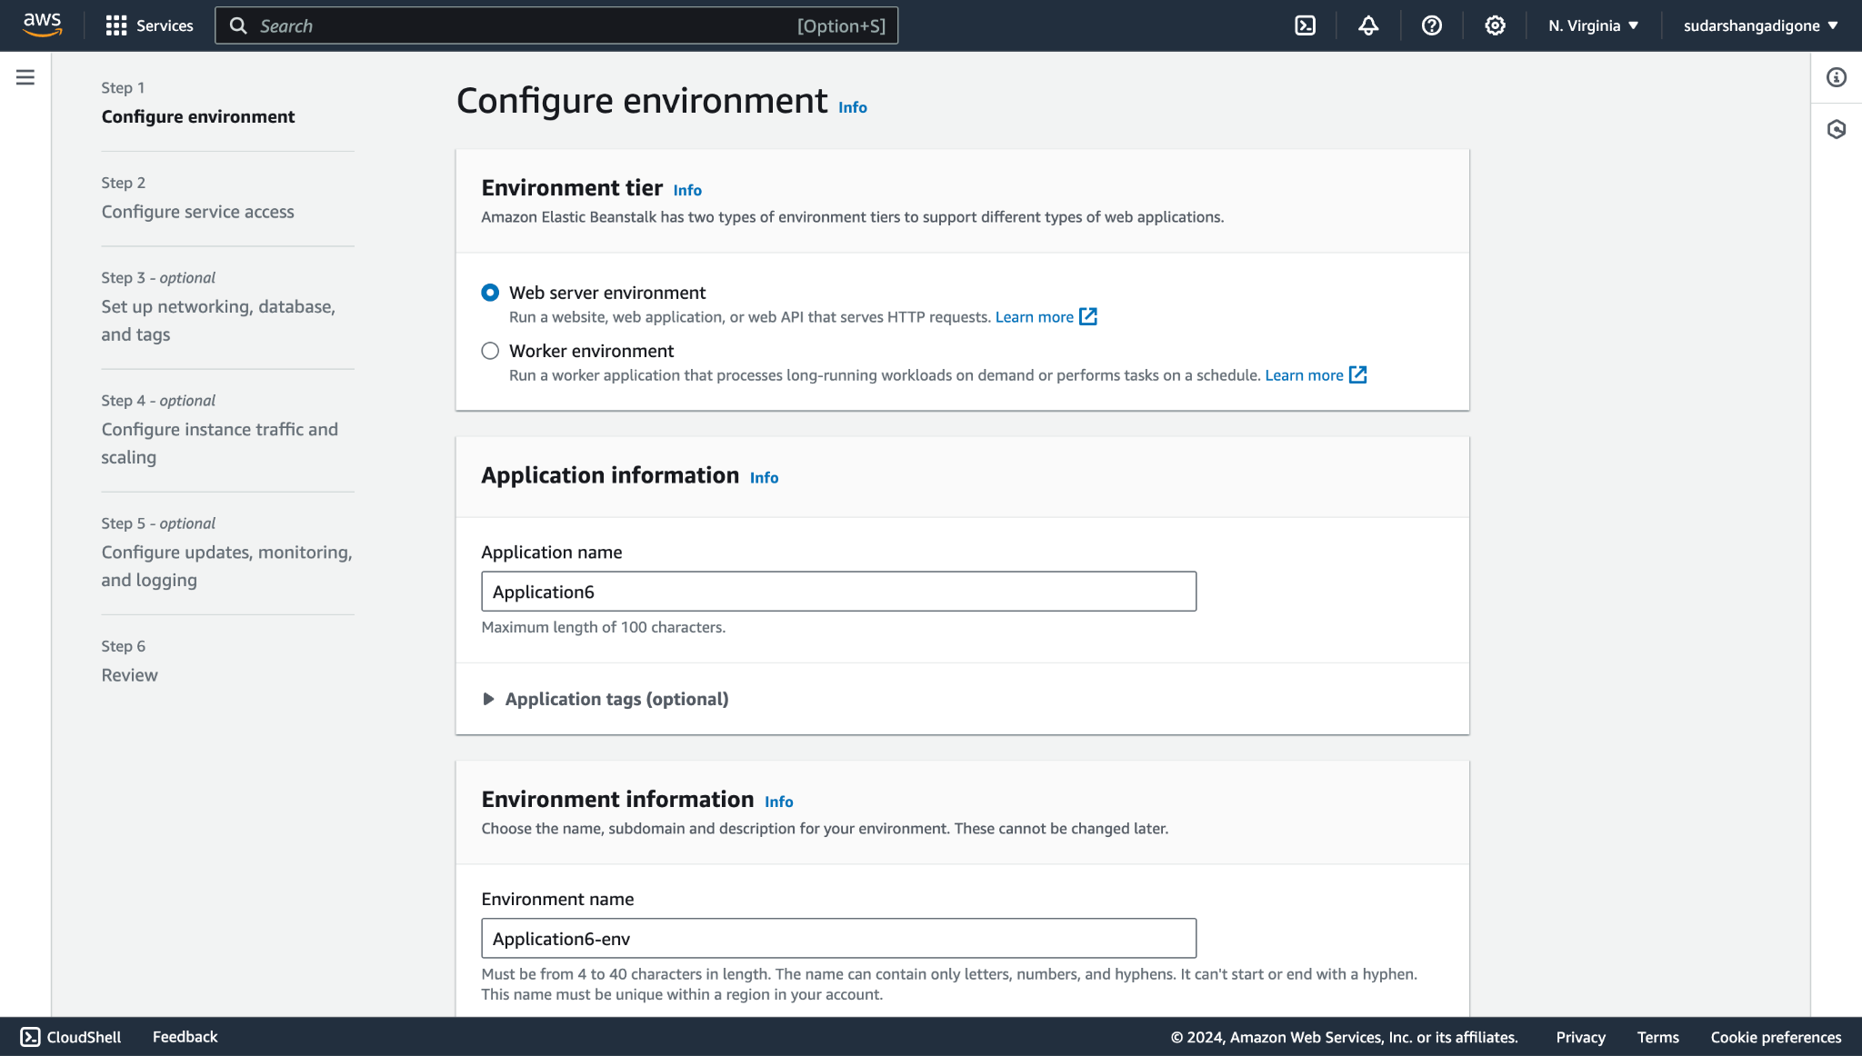

# **Step 3.** Move on to the platform option and select platform as Node.js then click on next and then click on submit after creating a new service role as per user’s needs.

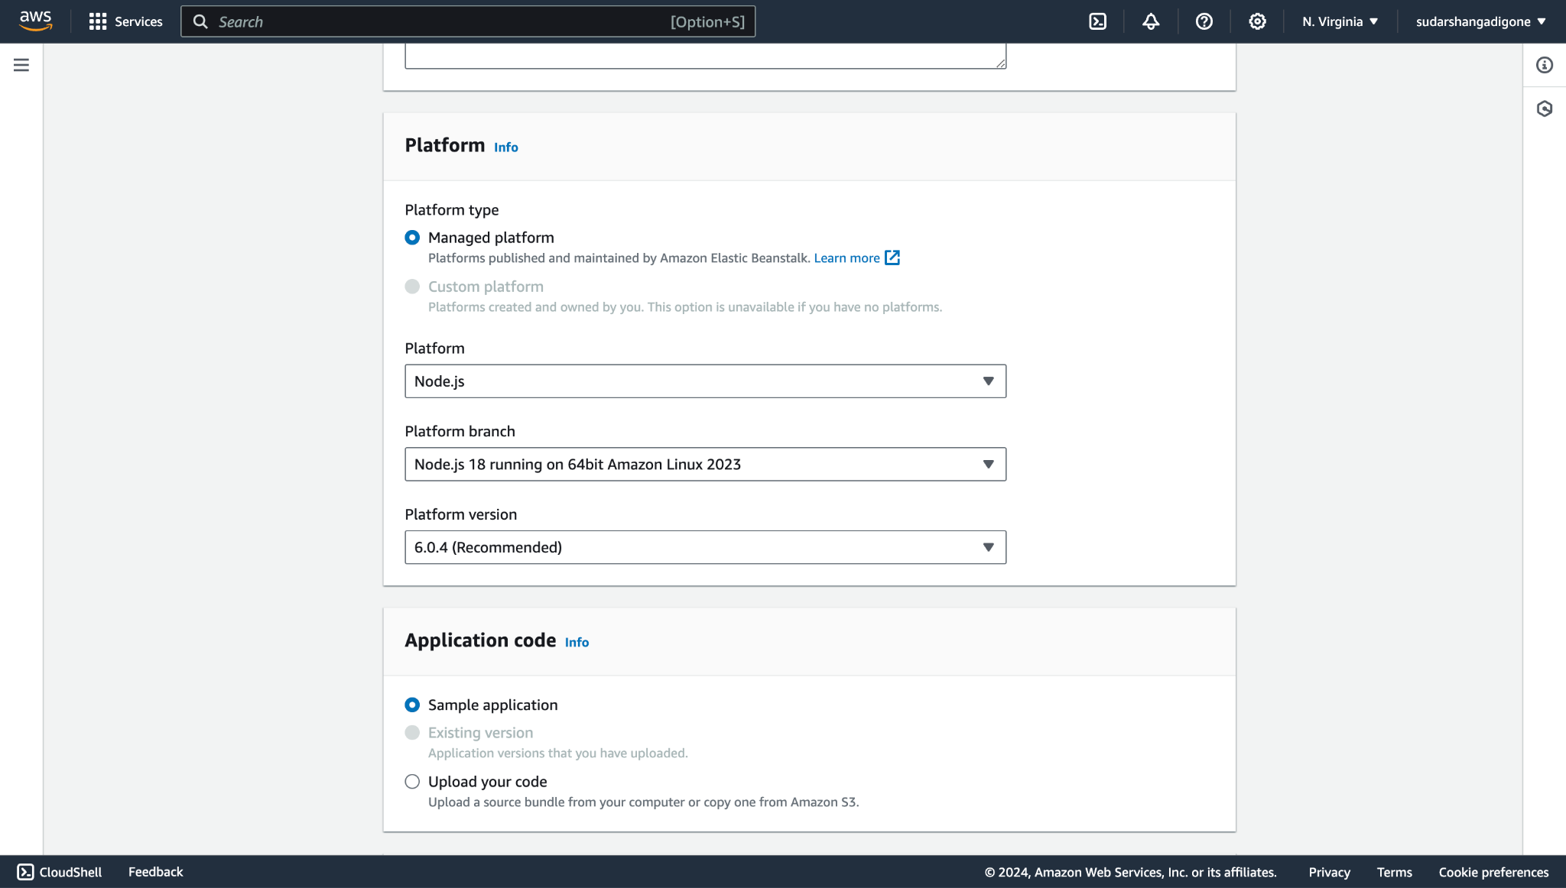

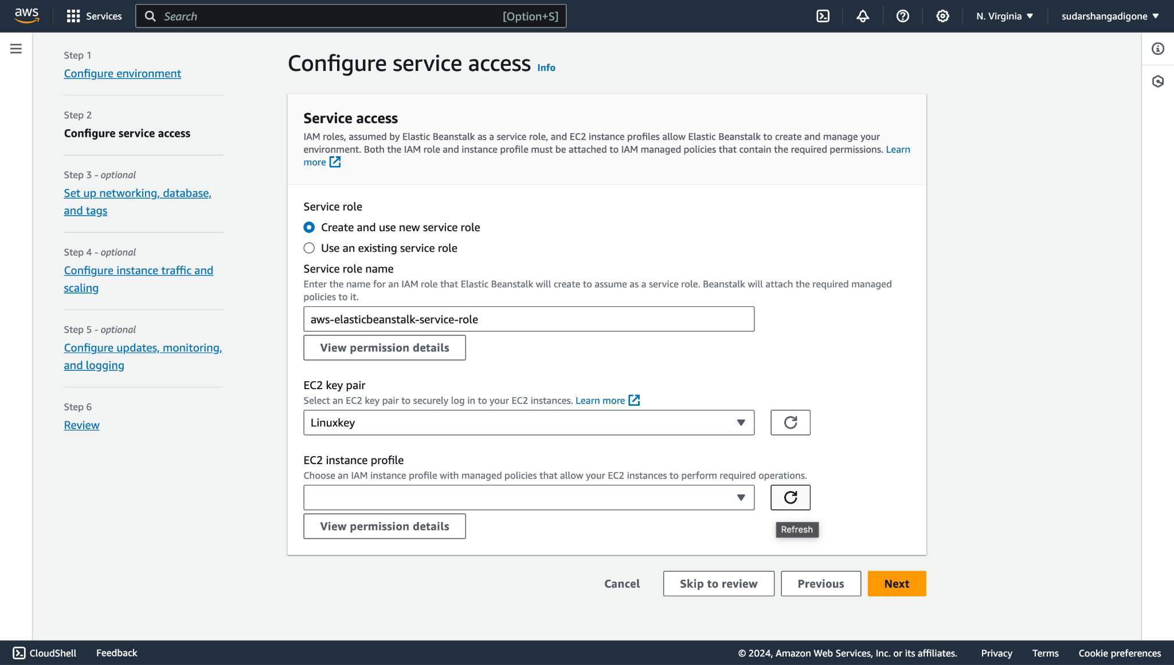

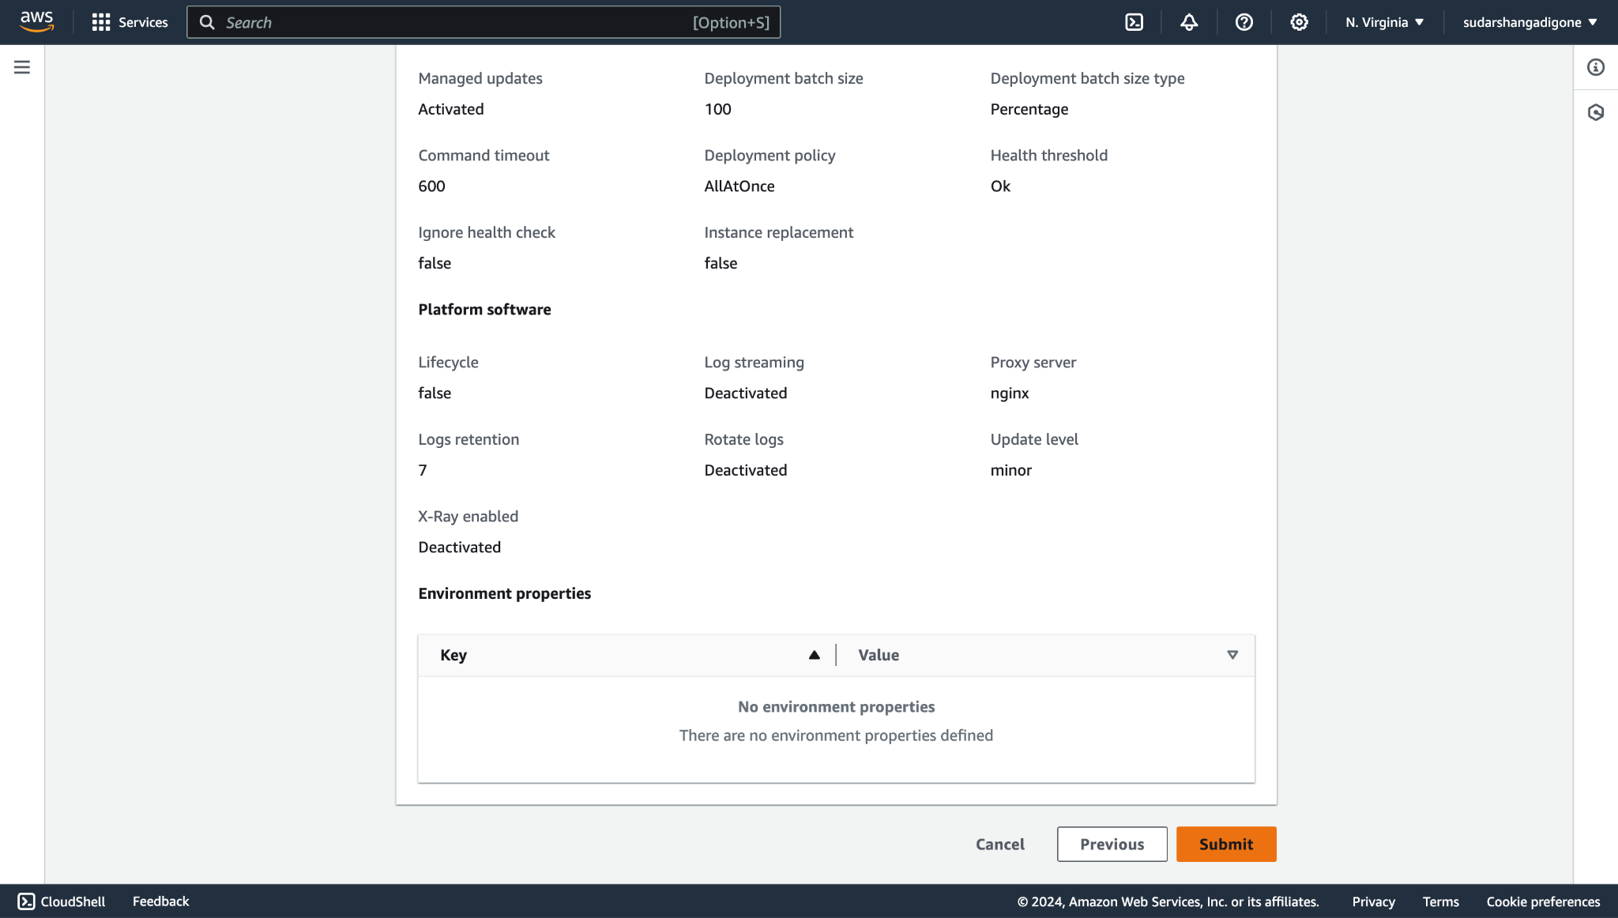

# 

# 

# 

# 

# 

# **Step 4.** Wait until theElastic Beanstalk is launching your environment.

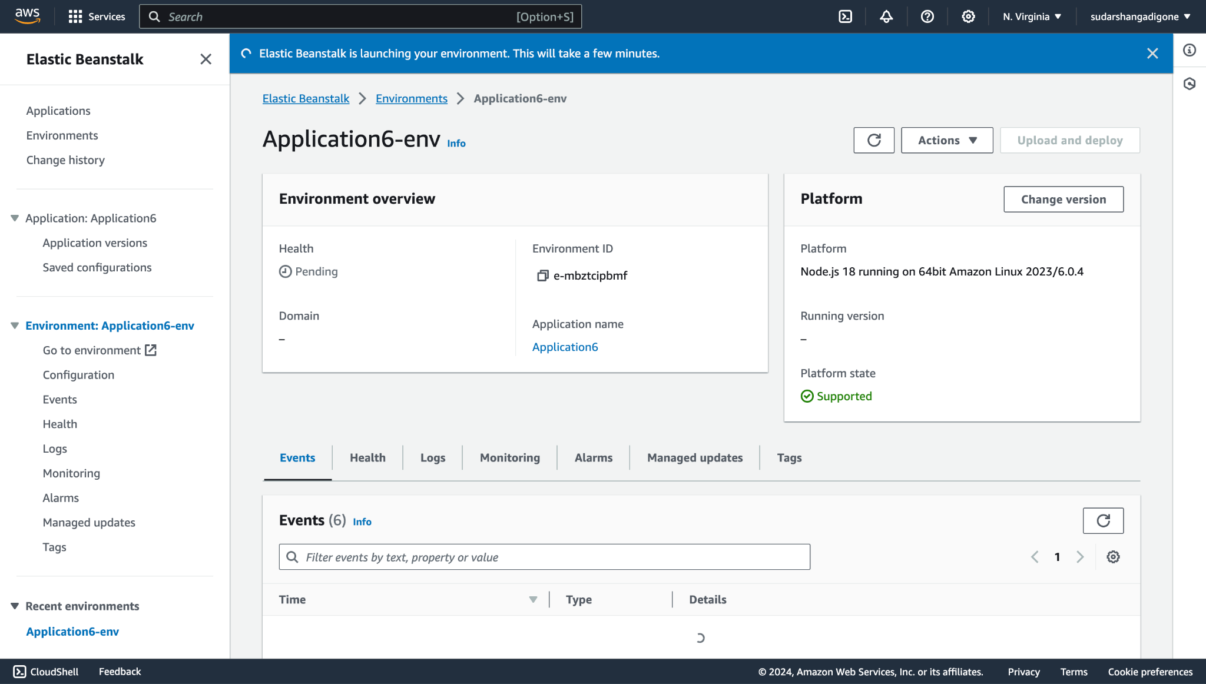

**Step 5.** When we click on the domain link we’ll be redirected to this page which shows us the application we created.

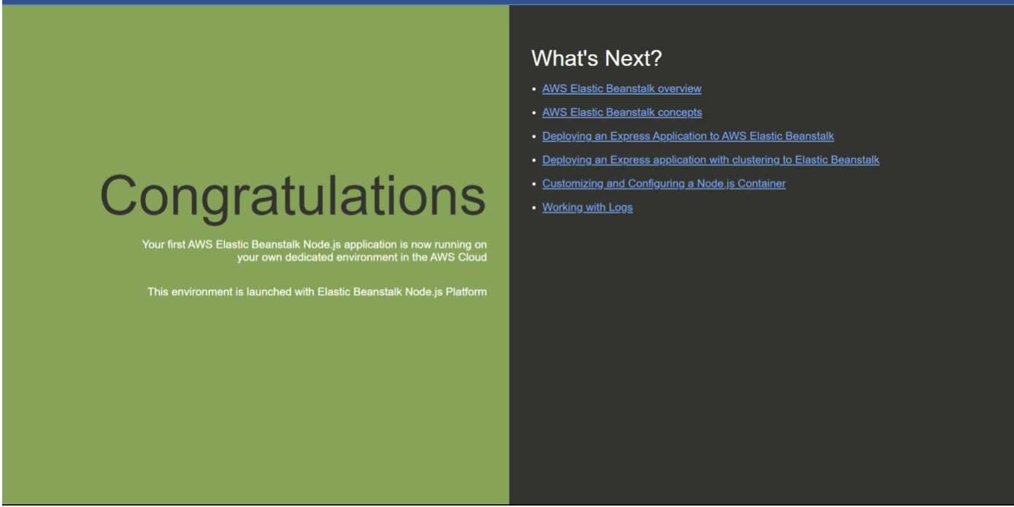

**CONCLUSION:**

Thus, we have created Elastic Beanstalk Server with NodeJs as a platform and ran a sample application on it .